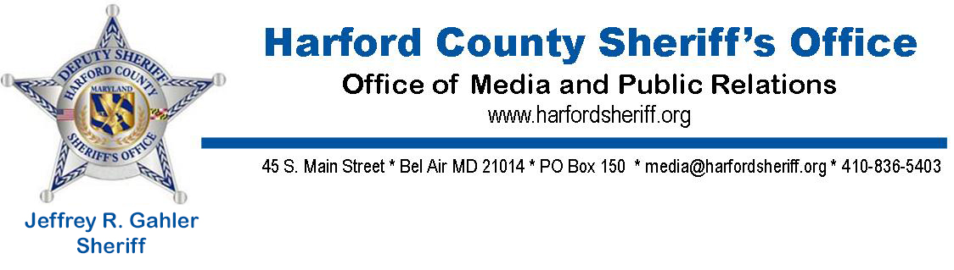
NEWS RELEASE
287(g) Successful in First Year of Implementation

For Immediate Release: Kyle Andersen, HCSO Media & Public Relations, 410-836-5224

[November 15, 2017, Bel Air, MD] On October 26, 2017, the Harford County Sheriff’s Office and US Immigration and Customs Enforcement (ICE) signed a Memorandum of Understanding formalizing the relationship between the two agencies and setting guidelines for the implementation of the Illegal Immigration Reform and Immigrant Responsibility Act, Section 287(g), known as the 287(g) program, at the Harford County Detention Center. Since that time, the program has proven to be hugely successful by allowing staff at the Harford County Detention Center the authority to strengthen public safety and enhance the safety and security of communities while ensuring consistency in immigration enforcement by prioritizing the arrest and detention of criminal aliens arrested locally for criminal violations.
The 287(g) program is a partnership between state and local correctional facilities and ICE permitting designated officers to perform immigration law enforcement functions, provided that the local law enforcement officers receive appropriate training and function under the supervision of ICE officers. In Harford County, each person arrested and processed in the Harford County Detention Center undergoes a preliminary screening, by trained correctional deputies, to determine if that person qualifies for ICE’s civil immigration enforcement priorities and processing for removal.
The Harford County Sheriff’s Office is the second of three agencies in Maryland that currently participate in the 287(g) program.
Following the launch of the 287(g) program at the Harford County Detention Center, nine Correctional Deputies underwent training to become certified Designated Immigration Officers and are now working under the purview of ICE’s 287(g) Program Manager. One additional deputy is scheduled to undergo training in January 2018.
Since the program’s inception at the Harford County Detention Center, 100 individuals arrested on State charges have been identified as needing further screening. Of those 100 individuals, 40 were identified as being both in this country illegally and a priority for removal procedures. The individuals identified as having been in the United States illegally were from countries throughout the world to include, but not limited to; El Salvador, Italy, Mexico, Kenya, Cuba, Vietnam and Jamaica. Additionally, it is important to note that those identified for action by ICE were arrested and charged by local law enforcement for various crimes including; Handgun on person, identity theft/fraud, CDS possession, second degree assault, armed robbery, and second degree murder. Out of the 40 suspects, five were validated as gang members, four of which are members of MS-13.
“The stats speak for themselves,” said Harford County Sheriff Jeffrey R. Gahler. “The decision for the Harford County Sheriff’s Office to take part in the 287(g) program was the right choice. Without question, adding this tool to our crime fighting tool belt helps protect Harford County residents. The ability to detain violent criminals and keep them from victimizing the citizens of Harford County is paramount. Without this program, violent criminals including four members of a violent gang could still be free and in our community.”
-30-

